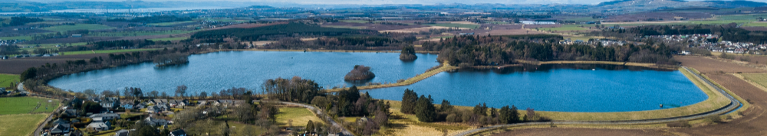
APPLICATION TO JOIN/REJOIN

MONIKIE ANGLING CLUB
The 2020 membership fee is £50 (plus £5 joining fee for new members), and includes a single angler voucher for any season 2020 evening session.
Please print and complete this form then send it, with an SAE and a cheque or postal order made payable to Monikie Angling Club, to:
Mr Steve Carmichael, 81 Dalhousie Street, Monifieth, DD5 4EP.
Alternatively, you can pay direct into the Monikie Angling Club bank account.
Sort Code: 83-17-01 Account Number: 00203697 Reference: JOIN
If using direct payment, please email treasurer@monikie-angling-club.org.uk with a breakdown of what you are paying for, after proceeding as above. NB – It is essential we also receive your printed form, together with an SAE.
Please read our Data Protection and Consent Policies before completing this form. By completing you consent to Monikie Angling Club using your information to provide you with the service you apply for. We will not share your information with third parties.

Full Name . . . . . . . . . . . . . . . . . . . . . . .. . . . . . . . . . . . . . . . . . Age . . . . . .

Address . . . . . . . . . . . . . . . . . . . . . . . . . . . . . . . . . . . . . . . . . . . . . . . . . . . . .

. . . . . . . . . . . . . . . . . . . . . . . . . . . . . . . . . . . . . Post Code . . . . . . . . . . . . . .

Membership No. (if applicable) . . . . . Email . . . . . . . . . . . . . . . . . . . . . . . . . . . . . . .

Telephone . . . . . . . . . . . . . . . . . . . . . . . Mobile . . . . . . . . . . . . . . . . . . . . . . . . .

Signed . . . . . . . . . . . . . . . . . . . . . . . . . . . . . . Date . . . . . . . . . . . . . . . . .

CLUB CHAMPIONSHIP
If you’d like to enter the Club Championship, please complete the following. Please include a remittance of £17 (Boat Charge) in the main table on Page 2.

Name . . . . . . . . . . . . . . . . . . . . . . . . . . . . . . . . . . . . . . . . . . . . . . . . . . . .

Address . . . . . . . . . . . . . . . . . . . . . . . . . . . . . . . . . . . . . . . . . . . . . . . . . . .

. . . . . . . . . . . . . . . . . . . . . . . . . . . . . . . . Postcode . . . . . . . . . . . . . . . . .

Phone . . . . . . . . . . . . . . . . . . . . . . . Membership No (if known) . . . . . .

Will you be using an electric motor? (Please circle) YES / NO
VOLUNTEER FOR BAILIFF DUTY
Please complete this part if you wish to be considered for bailiff duties.

Name . . . . . . . . . . . . . . . . . . . . . . . . . . . . . . . . . . . . . . . . . . . . . . . . .

Address . . . . . . . . . . . . . . . . . . . . . . . . . . . . . . . . . . . . . . . . . . . . . . .

. . . . . . . . . . . . . . . . . . . . . . . . . . . . Postcode . . . . . . . . . . . . . . . . .

Phone . . . . . . . . . . . . . . . . . . . . . . . . Membership No (if known): . . . . . .

Availability (Please circle) Day / Evening / Weekend

LAUNCHING, REMOVAL AND MAINTENANCE OF BOATS 2020
Any member willing to assist please complete the following:

Name . . . . . . . . . . . . . . . . . . . . . . . . . . . . . . . . . . . . . . . . . . . . . . . .

Membership No (if known) . . . . . . Phone . . . . . . . . . . . . . . . . . . . . . .

Boat Convenor will contact you to advise dates and times.

My membership application fees include: | Fee | Number | Total
New Member Joining Fee | £5
Annual Membership (juniors under 18 free) | £50
Single boat discount voucher | £15
Double boat discount voucher | £30
Club Championship boat charge | £17
Angus Angling rod, reel or line raffle | £7
Box with flies raffle (tied by Aaron Phillip) | £7
Ballot for Opening Day (Y/N in Number col)
Donation
Grand Total
Paying by Bank Transfer (Please circle) |  | YES | NO

Thank you for your application and TIGHT LINES for season 2020!
NB – all membership renewals must be paid by February 29.

